**HO CHI MINH UNIVERSITY OF TECHNOLOGY AND EDUCATION FALCUTY FOR HIGH QUALITY TRANING**



**Lecturer: NGUYEN DUC KHOAN**

**FINAL PROJECT**

**TOPIC: BOOK STORE**

**ATTENDEES:**

**BUI TUAN ANH - 17110001**

**LE PHUONG NAM - 17110054**

**HO LE THONG - 17110077**

**SEMESTER: 1 – SCHOOL YEAR: 2019 – 2020**

**HO CHI MINH CITY – 11.2019**

*Topic: Book Store*

Contents

CHAPTER 1: PROJECT CHARACTERISTICS 4

1.1. Project target 4

1.2. Project range 4

1.3. Technology used 4

1.4. Data 5

1.5. Create a database in SQL Server 7

CHAPTER 2: Controllers 10

2.1. AdminController 10

2.2. BookController 10

2.3. UserController 10

CHAPTER 3: USER INTERFACE 11

1. Login Form 11

2. Register Form 11

3. Main User Interface 12

4. Book Detail 13

3. Book Management 13

4. Cart 14

CHAPTER 4: SUMMARY 14

4.1. The advantages and disadvantages of the project 15

PLANNING TABLE 15

REFERENCES 16

**INTRODUCTION**

To make any project, essential requirement is able guidance and references without which project is incomplete. We are very much thankful to Mr. Nguyen Duc Khoan who has provided us an opportunity and motivation to gain knowledge through this type of project. We will get practical knowledge from this project and this will help us a lot in our career.

The present is not free of limitation. There might have problem regarding lack of limitation in some aspects and also some minor mistakes such as typing mistakes. I apologize if any error is found which was deliberately made. Please feel free to contact me if any question arises.

Thank you!

***COMMENT OF THE INSTRUCTOR***

................................................................................................................................................. ................................................................................................................................................. ................................................................................................................................................. ................................................................................................................................................. .................................................................................................................................................

................................................................................................................................................. .................................................................................................................................................

.................................................................................................................................................

.................................................................................................................................................

................................................................................................................................................. ................................................................................................................................................. ................................................................................................................................................. .................................................................................................................................................

................................................................................................................................................. .................................................................................................................................................

.................................................................................................................................................

................................................................................................................................................. ................................................................................................................................................. ................................................................................................................................................. ................................................................................................................................................. ................................................................................................................................................. ................................................................................................................................................. .................................................................................................................................................

................................................................................................................................................. .................................................................................................................................................

INSTRUCTOR

# 

# CHAPTER 1: PROJECT CHARACTERISTICS

### 1.1. Project target

Develop a program to manage and buy book. There are features such as edit book, edit publisher, add book,...

### 1.2. Project range

Given a web project which for selling and manage book.

### 1.3. Technology used

We use Entity Framework which is an object-relational mapper (O/RM) that enables .NET developers to work with a database using .NET objects. It eliminates the need for most of the data-access code that developers usually need to write.

Model–view–controller (usually known as MVC) is a [software design pattern](https://en.wikipedia.org/wiki/Software_design) commonly used for developing [user interfaces](https://en.wikipedia.org/wiki/User_interface) which divides the related program logic into three interconnected elements. This is done to separate internal representations of information from the ways information is presented to and accepted from the user. Following the MVC architectural pattern decouples these major components allowing for [code reuse](https://en.wikipedia.org/wiki/Code_reuse) and parallel development.

• Describe by words

When user want to turn on Book application, they have to input username and password.

To manage the book list, we need the following data:

* **Account**

Each user have a username to manage or buy => need “username” => has to be primary key.

* **Sach**

Each book have a MaSach to be manage or buy => need “MaSach” => has to be primary key.

### 1.4. Data

* Relational Schema

|  |  |
| --- | --- |
| Username | password |
| varchar(100) | varchar(100) |

|  |  |  |  |  |
| --- | --- | --- | --- | --- |
| HoTen | NgaySinh | GioiTinh | DienThoai | username |
| nvarchar(100) | date | bit | varchar(11) | varchar(100) |

|  |  |  |  |  |  |
| --- | --- | --- | --- | --- | --- |
| HoTen | NgaySinh | GioiTinh | DienThoai | username | NguoiThem |
| nvarchar(100) | date | bit | varchar(11) | varchar(100) | varchar(100) |

|  |  |
| --- | --- |
| MaTheLoai | TheLoai |
| int | nvarchar(100) |

|  |  |  |  |
| --- | --- | --- | --- |
| MaTacGia | TenTacGia | DiaChi | DienThoai |
| int | nvarchar(100) | nvarchar(100) | varchar(11) |

|  |  |  |  |  |
| --- | --- | --- | --- | --- |
| MaDonHang | DaThanhToan | NgayDat | NgayGiao | username |
| int | int | date | date | varchar(100) |

|  |  |  |  |  |  |  |
| --- | --- | --- | --- | --- | --- | --- |
| MaSach | TenSach | GiaBan | Mota | MaTheLoai | Soluong | MaTacGia |
| int | nvarchar(100) | money | nvarchar(200) | int | int | int |

|  |  |  |  |
| --- | --- | --- | --- |
| MaDonHang | MaSach | SoLuong | DonGia |
| int | int | int | nvarchar(10) |

* Diagram

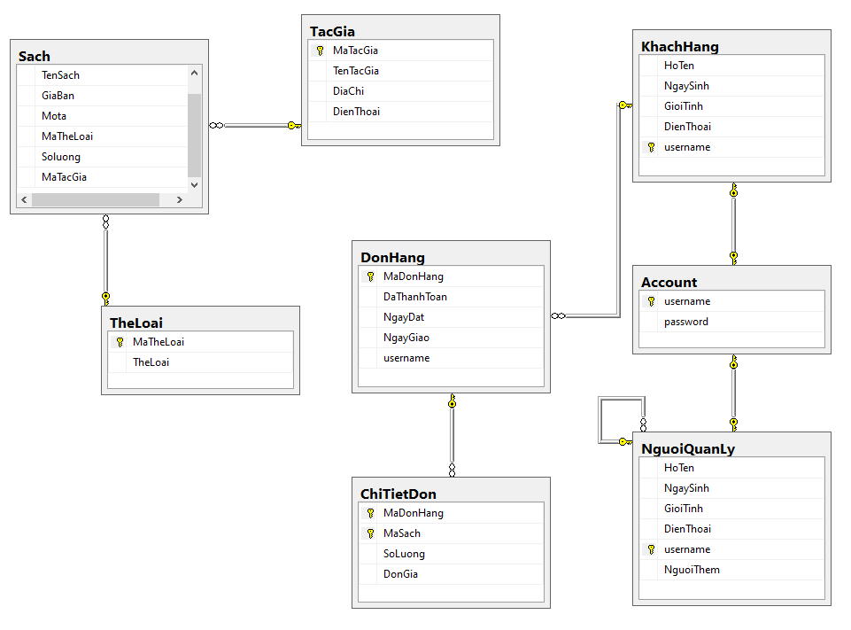

* Entity Relationship Diagram

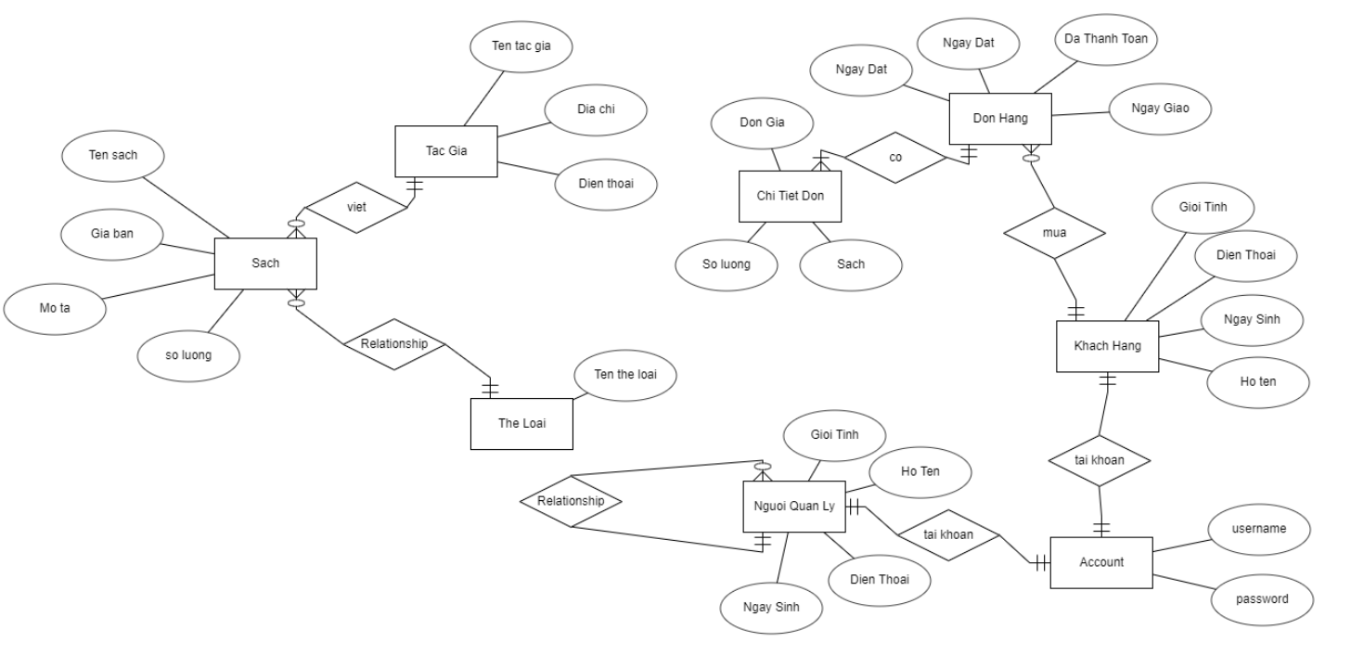

### 1.5. Create a database in SQL Server

create table Account

(

username varchar(100) PRIMARY KEY not null,

password varchar(100),

)

go

create table KhachHang

(

HoTen nvarchar(100),

NgaySinh date,

GioiTinh bit,

DienThoai varchar(11),

username varchar(100) FOREIGN KEY REFERENCES Account(username) not null

CONSTRAINT PK_KhachHang PRIMARY KEY (username)

)

Go

create table NguoiQuanLy

(

HoTen nvarchar(100),

NgaySinh date,

GioiTinh bit,

DienThoai varchar(11),

username varchar(100) FOREIGN KEY REFERENCES Account(username) not null,

NguoiThem varchar(100) ,

CONSTRAINT PK_NguoiQUanLy PRIMARY KEY (username),

CONSTRAINT FK_NguoiQuanLy_NguoiQuanLy FOREIGN KEY (NguoiThem) REFERENCES NguoiQuanLy(username)

)

Go

create table TheLoai

(

MaTheLoai int primary key,

TheLoai nvarchar(100)

)

go

create table TacGia

(

MaTacGia int primary key ,

TenTacGia nvarchar(100),

DiaChi nvarchar(100),

DienThoai varchar(11)

)

go

create table DonHang

(

MaDonHang int primary key,

DaThanhToan int not null,

NgayDat date not null,

NgayGiao date not null,

username varchar(100) not null

foreign key (username) references KhachHang(username),

)

go

create table Sach

(

MaSach int primary key,

TenSach nvarchar(100),

GiaBan money,

Mota nvarchar(200),

MaTheLoai int ,

Soluong int ,

MaTacGia int,

foreign key (MaTheLoai) references dbo.TheLoai(MaTheLoai) on delete set null,

foreign key (MaTacGia) references dbo.TacGia(MaTacGia) on delete set null,

)

go

create table ChiTietDon

(

MaDonHang int not null,

MaSach int,

SoLuong int not null,

DonGia nvarchar(10),

foreign key (MaDonHang) references dbo.DonHang(MaDonHang),

foreign key (MaSach) references dbo.Sach(MaSach) on delete set null

)

go

# CHAPTER 2: Controllers

### 2.1. AdminController

This controller will return Admin View. This also have a CreateNew to add New data into our Database by using Entity Framework.

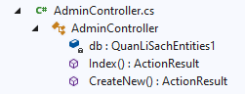

### 2.2. BookController

This controller has the most function: Delete Cart, Add Cart, Update Cart, Detail book,...

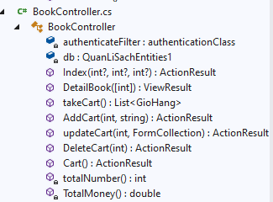

### 2.3. UserController

As you can see the main function is Login and Register.

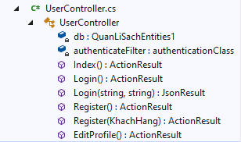

# CHAPTER 3: USER INTERFACE

## 1. Login Form

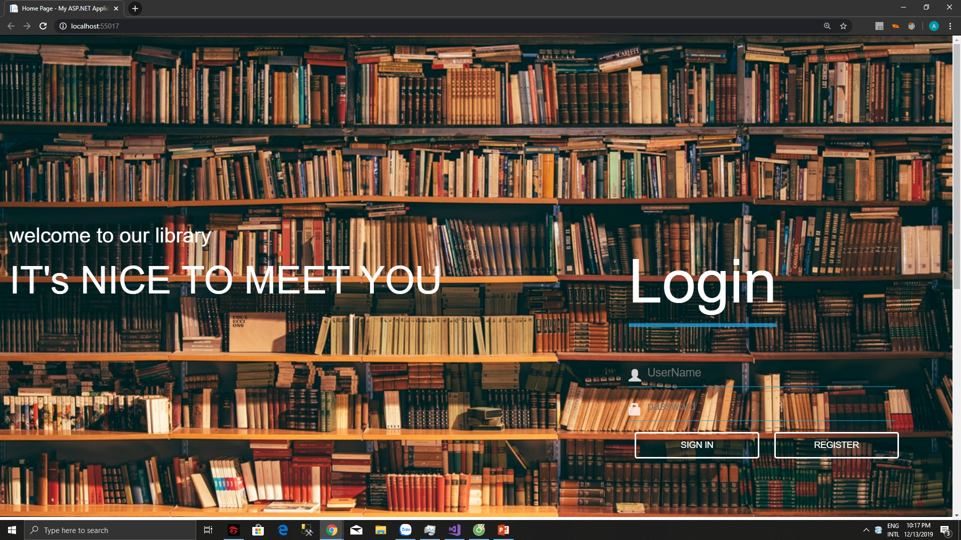

This is the login, which is first step to get into our web, if you don’t have the account, you can make the new one by Register.

In our web, you must have an account or you can not access our Website.

## 2. Register Form

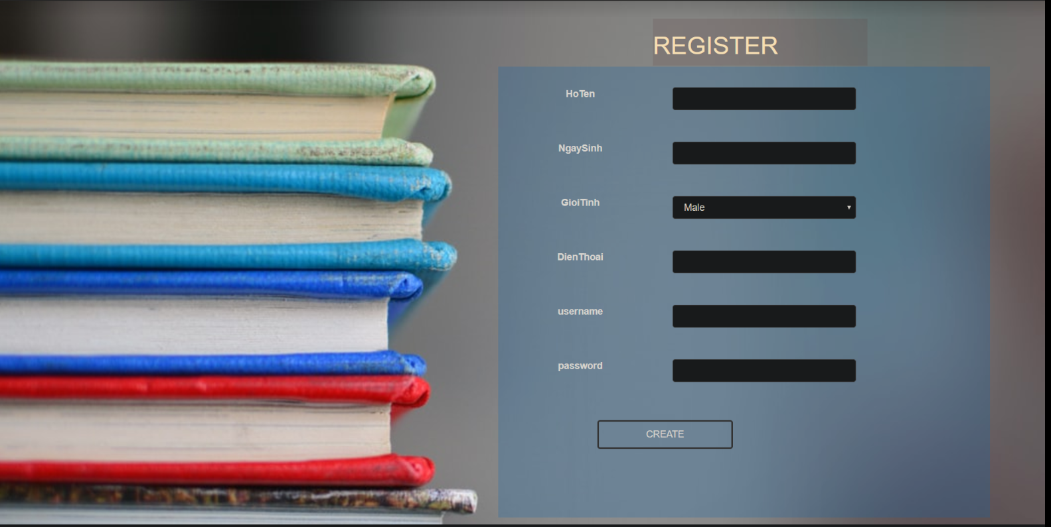

This is the register form. If user do not have account to login the website, user can create here

## 

## 3. Main User Interface

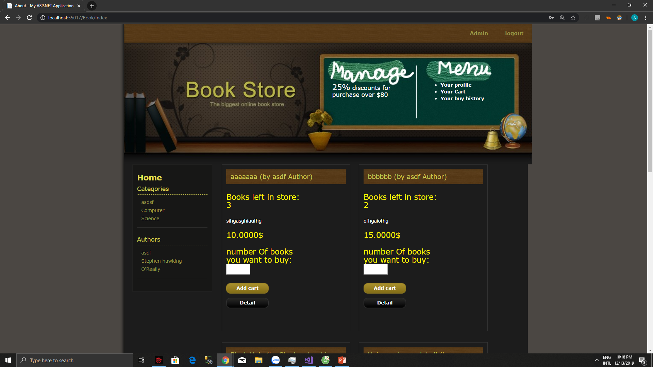

This page use for buy the book, you need select its number of books then add it to cart to complete buying stuff.

We also make a filter for user can find favorite Authors and kind of books.

## 3. Book detail

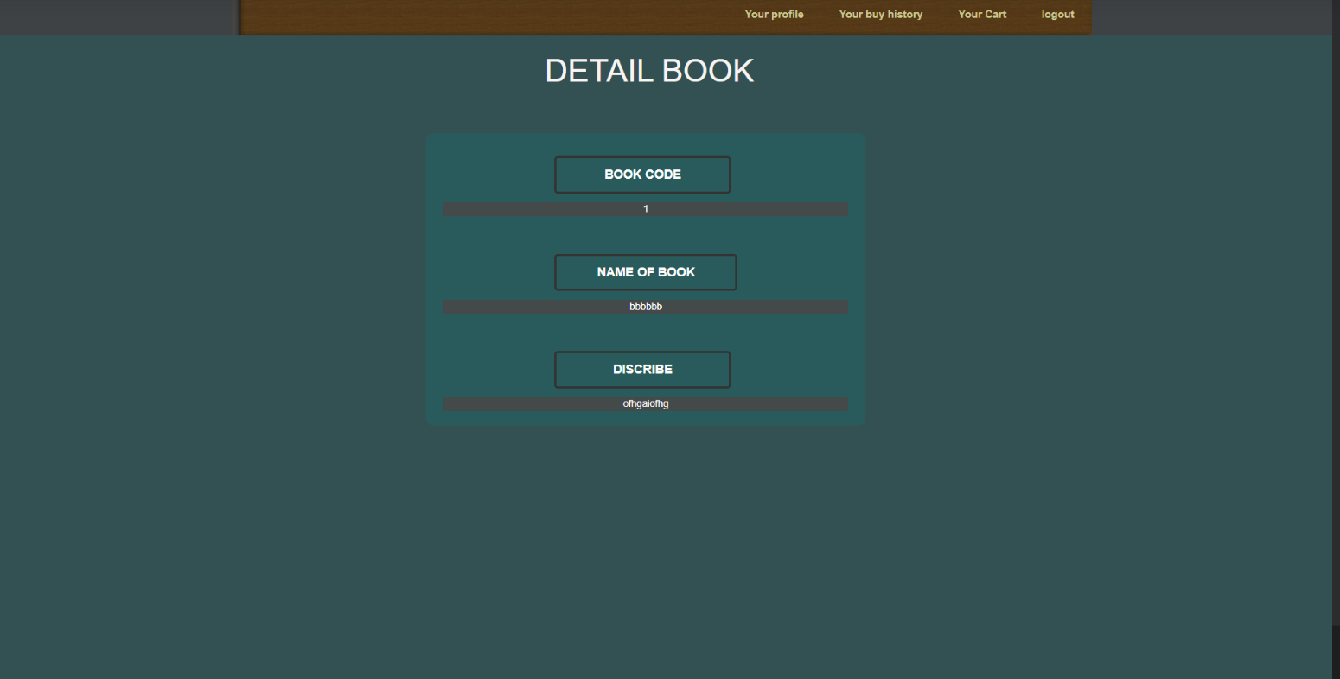

If user need more detail of book, this form will show more information of book

## 5. Book Management

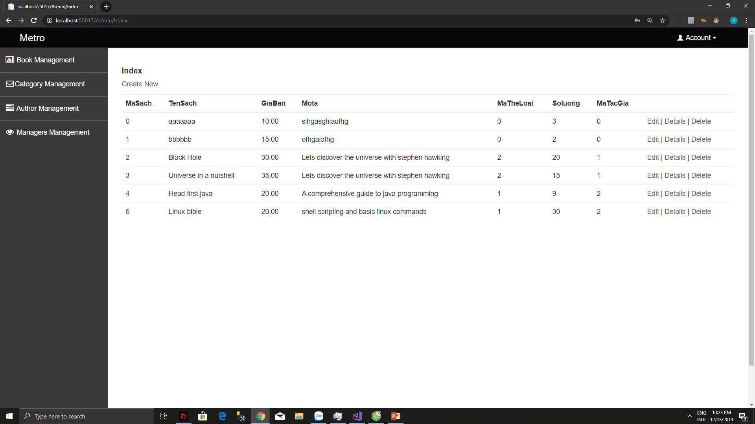

The page Book Management has some functions: Add, Update, Delete,... The detail wil show you the information of book and Admin can update or delete it. Admin also can manage the author.

## 6. Cart

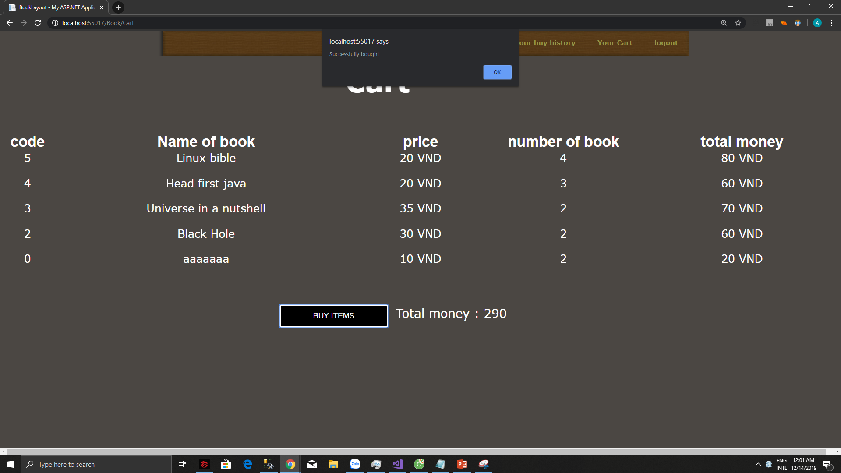

The page count the number of books you added then show you the total you must paid for. The currency unit is VND(VietNamDong ).

# CHAPTER 4: SUMMARY

### 4.1. The advantages and disadvantages of the project

#### 4.1.1. The advantages

We have made a project that had an easy-to-use UI so the users will face no obstacles to use this program. Besides that, the code is quite clean and clear.

The program also cost a little capacity.

#### 4.1.2. The disadvantages

The algorithms are not completely optimized. Some bugs still occur when we run the program in some specific test cases. We plan to build this program to be more efficient.

# PLANNING TABLE

|  |  |  |  |  |  |  |
| --- | --- | --- | --- | --- | --- | --- |
| **Week** | **Job** | **Time** | **Product** | **Attendee** | **Completion day** | **Rate** |
| 1  From  28/10/2019 To  03/11/2019 | 1. Find references | 28/10 | - Planning tasks | All  members | 29/10 | 100% |
| 2.  Planning | 29/10 |  | All  members | 29/10 | 100% |
| 3. Work assignment | 29/10 |  | Leader:  Bùi Tuấn Anh | 29/10 | 100% |
| 4. First part of the  report | 29/10  – 1/11 | - Complete  the first part of the report | - Hồ Lê  Thông | 1/11 | 100% |
| 5. Design  UI | 1/11 –  3/11 | - Complete the User Interface of the  Program | - Lê Phương Nam | 3/11 | 100% |
| 2  From  4/11/2018  To  10/11/2018 | 1.  Complete general UI,  Menu, | 4/11 -  6/11 | - General UI | - Lê Phương Nam | 6/11 | 100% |

|  |  |  |  |  |  |  |
| --- | --- | --- | --- | --- | --- | --- |
|  | Buttons,  Logo, Icon |  |  | - Lê Phương Nam |  |  |
| 2.  Generate necessary properties, build Class | 7/11-  9/11 | - Main  Class | - Bùi Tuấn Anh | 9/11 | 100% |
| 3. Build first controller | 10/11 |  | - Bùi Tuấn Anh, Lê Phương Nam, Hồ Lê Thông | 10/11 | 100% |
| 3  From  11/11/2018 To  17/11/2018 | 1. Testing | 11/11-  15/11 | - Try some test cases | Bùi Tuấn Anh | 15/11 | 100% |
| 2. Make report for the main contents (P1) | 16/11-  17/11 | - Report for first part | - Hồ Lê  Thông | 17/11 | 100% |
| 4  From  18/11/2018 To  24/11/2018 | 1.  Complete remaining parts | 18/11-  20/11 |  | - All  members | 20/11 | 100% |
| 2.  Complete some functions | 21/11-  22/11 |  | - Bùi Tuấn Anh, Lê Phương Nam | 22/11 | 100% |
| 3. Make report for the main contents (P1) | 23/11-  24/11 |  | - Hồ Lê  Thông | 24/11 | 100% |
| 4. Testing | 24/11 |  | - All  members | 24/11 | 100% |
| 5  From  25/11/2018  To  28//2018 | 1. Adding some sub functions | 25/11  –  26/11 |  | - Bùi Tuấn Anh |  | 100% |
| 2. Do the last part of the report | 25/11  -26/11 |  | - Hồ Lê  Thông |  | 100% |
| 4.  Complete program, review the report | 27/11  -28/11 |  | - All  members |  | 100% |

# REFERENCES

<https://vi.pngtree.com/>

<https://www.w3schools.com/>

<https://docs.microsoft.com/en-us/ef/>

<https://docs.microsoft.com/en-us/aspnet/mvc/overview/getting-started/introduction/getting-started>